Public Engagement with Research Awards 2018
Have you delivered an innovative public engagement project? Have you engaged the public or patients during a research project to help shape your research? Have you used co-creation, participatory action research or co-design in your research?

The Public Engagement with Research awards aim to recognise people for excellent public engagement (PE) or patient and public involvement and engagement (PPIE) and to raise awareness of innovative high-quality practice. There are three awards of £400 each.

The Public Engagement with Research awards are part of a strategic programme of activities that aim to embed PE and PPIE as a standard, valued activity for University of Leeds staff and PG students. New academic promotions criteria include public engagement activity and having received a Public Engagement award might help you with your next career move.

Eligibility criteria
- Applications are made via an application form
- Submissions are open to all members of staff and PG students as individuals or teams
- Submissions are open from all disciplines
- The activity must have been completed and have taken place within the last 24 months
- PE and PPIE activities must be based on and enhance research projects from the University of Leeds
- Outreach activities that serve student recruitment, widening participation, general promotion of higher education or of a particular area of study will not be considered

Public Engagement with Research Award Categories:

We encourage PE/PPIE to be applied in all three main stages of the research cycle: developing the research idea, doing the research itself and disseminating the research results.

Award for outstanding PE/PPIE: development of a research idea
This award recognises activities that have achieved demonstrable input into shaping research projects or questions through working in partnership with the public/groups of the public during the development of the research idea

Award for outstanding PE/PPIE: doing research in partnership
This award recognises activities where researchers worked in partnership /collaboration or co-creation with groups of the public carrying out the research.

Award for outstanding PE/PPIE: disseminating research results
This award recognises activities where researchers have shared, disseminated knowledge or inspired the public.

Public Engagement with Research Awards 2018: Information for applicants

How do I apply?
Applications are made via a form. Your completed form should not be longer than four pages of A4 in 11pt text. Applications longer than this, or in a different text size will not be considered.
Please submit your application to peteam@leeds.ac.uk by Monday, 15 October 2018 23:59 BST

After submission your application will be screened for eligibility by the PE team and then assessed by the entirely external reviewer panel. Awards are at the judges’ discretion.

Members of the reviewer panel are:
- Dr Steve Dorney, Director of Public Engagement with Research, University of Southampton
- Kimberley Freeman, Executive Officer for Public Engagement and Director of the Centre for Public Engagement at Queen Mary University London
- Lewis Dean, Programme Manager – Public Engagement, UKRI
- Dr Lesley Paterson, Head of Public Engagement with Research, Oxford University
- Dr Rebecca Jones, Research and Engagement Relationships Manager, Wellcome Trust
- Paul Manners, Director, National Co-ordinating Centre for Public Engagement

Award Ceremony November 2018
All applicants are asked to attend the award ceremony on 15 November 2018, 12-2 pm and award winners will be announced at the ceremony. Each award winner will receive £400 to be paid into a University account. We encourage you to use this money towards PE/PPIE activities in a way that benefits you most.

The application form
- Please give us some details about you and your team members (if applicable).

- Select which category award you are applying for. The figure below shows the three major stages of the research cycle. One award is associated with each of these major stages. Select the stage your PE/PPIE activity enhanced.
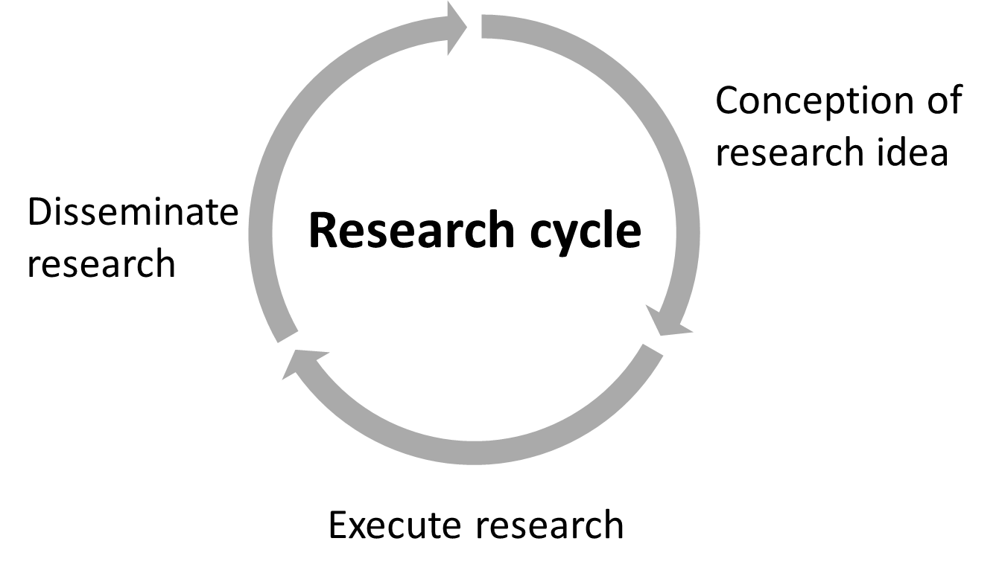
- Please tell us when your PE/PPIE activity took place. The activity must be completed and have started at the earliest in May 2016.

- The STAR-framework for PE/PPIE
The PE team have developed a framework for PE and PPIE to support staff members with the identification of the reasons why they are doing PE/PPIE activities. The four aims for PE/PPIE form the pillars of the STAR-framework. The four pillars are:

Social responsibility:
We are open about the research that is taking place at our institution, we are embedded in societal evolution, we respond to and shape the external context in which we operate, we contribute to social mobility.
Trust:
We strengthen the relationship between the University and wider community and secure trust in the research carried out at the University. We establish a reputation as an accessible and approachable institution, willing to listen to partner organisations and audiences beyond universities; this enhances partnerships and builds foundations for future relationships for engaged and impactful research.
Accountability:
We are funded by public money and hence are accountable to the public. Working in partnership with audiences beyond universities in mutually beneficial ways makes sure the purpose and impact of our research are understood and valued by wider society.
Relevance:
We ensure that research conducted is relevant to society’s needs and has impact on society. Research outputs are easily accessible and widely used, innovation flourishes as new ideas and insights are exchanged and people see research careers as relevant and attractive.

An individual PE/PPIE activity will have project-specific objectives that can be aligned to the overarching aims. Therefore an individual PE/PPIE activity will contribute to the overarching aims of PE/PPIE. By being clear about objectives, it is easier to think about the evaluation of objectives. In general, we recommend to have about 2-3 objectives for an individual activity to keep the workload realistic.
Using the STAR framework, select up to two aims your PE/PPIE activity contributed to (in case the activity contributed to more than two select the top two). Download the STAR framework here: http://comms.leeds.ac.uk/wp-content/uploads/sites/7/2017/01/STAR-v1.0-sheet.xlsx

- What research project is/was the PE/PPIE activity linked to?
We would like to celebrate activities that have a clear link to a research project. Please describe yours briefly.
- Please list the objectives of your PE/PPIE activity.
As outlined under the STAR-framework, your activity will have had some objective(s). Please list them here. This is not the same as the aims you selected earlier, e.g. an objective could be: to be able to adapt language to the needs of an audience, which could align to the trust aim because people will only develop trust in academia when they can understand what is being said.
- Please briefly describe your PE/PPIE activity?
What was the activity, where did it take place?
- Who was your target audience and why did you choose it?
Apart from stating who your target audience was, please let us also know why you chose this audience.
- What challenges did you have in planning/organising/running/evaluating your PE/PPIE activity and how did you overcome these?
Feel free to share challenges and solutions. If you didn’t have any challenges, then please say so. The reason for the question is to help us, the PE team, to identify common challenges and potentially address these in the future.
- What was innovative/creative about your PE/PPIE activity?
This might be something you did in order to pre-empt an anticipated challenge or you changed your practice based on experience, being inspired by someone else …
- How did you evaluate your PE/PPIE activity?
How do you know that you have achieved your objectives? Whatever form of evaluation you used, please describe it.
- What is different/has changed as a result of the PE/PPIE activity?
This might include change in yourself, your research, your relationship with the public or perhaps in relation to your set objectives.
- What do you think makes your activity a notable example for high quality engagement?
Please tell us why you think your engagement activity is of high quality and what is it that makes you particularly proud of it.

