Bradford Science Festival 2019 Contributor Guidance
Lates Festival Launch 18th July
Family Science Festival 20th - 21st July

Welcome and Thank You
Thank you for your interest in being part of Bradford Science Festival 2019 (BDSF19). We hope this information pack will tell you everything you need to know about the Festival and how we work in collaboration with partners. We would love to hear from you, so if you have any questions or would like to know more, please do not hesitate to get in touch with the team – our details are at the end of this document.

The Bradford Science Festival is….
- A Science Festival based in Bradford and primarily for the people of Bradford and wider Yorkshire and Humberside.
- A Festival which responds to, and works with the diverse local population, inspiring them to see that STEM is for them.
The Bradford Science Festival aims to…
- Grow Science Capital in individuals especially those living in Bradford District.
- Deliver interactive, fun and inspiring STEM learning which is open and accessible to all.
- Deliver a high-quality Festival which creates a sense of pride in the city.
- Showcase Bradford as being a great city in which to study science and to work in STEM related careers.
- Create opportunities for diverse communities to interact and share learning opportunities together.
The Bradford Science Festival believes…
- That STEM learning should be accessible and engaging for all and that children and young people with low science capital should have access to fun and interactive STEM learning opportunities both in school and with their families.
- We believe that increased Science Capital in the local population can and will support the economic regeneration of the Leeds City Region.
Produced by the National Science and Media Museum, which is part of the Science Museum Group, Bradford Science Festival’s mission is to inspire curiosity, encourage discovery and instil wonder making science fun and inclusive for all. Embedded in the city centre and delivered by multiple partners the festival aims to inspires the people of Bradford to explore the surprising science in their city. Having launched in 2017, we believe we are now the most diverse science festival in England.
Lates Festival launch event
highest ever attendance 1107
Busiest weekend in the Museum 2018

Total visitors to BDSF18 34,500

Highlights from Bradford Science Festival 2018
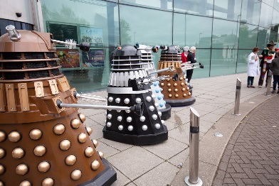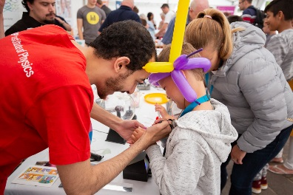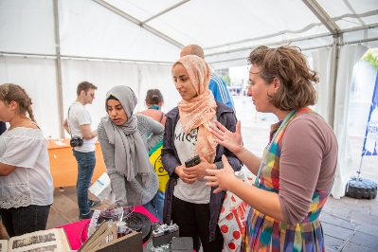
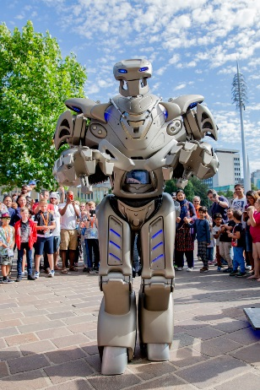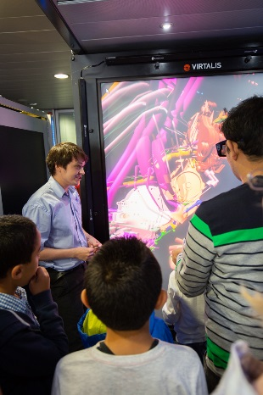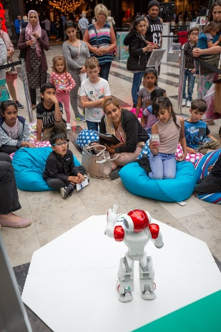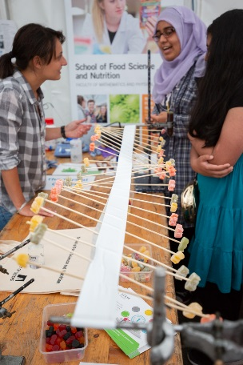
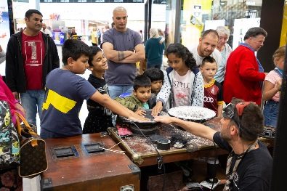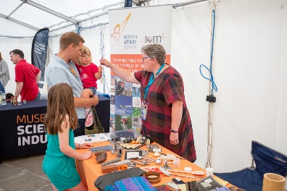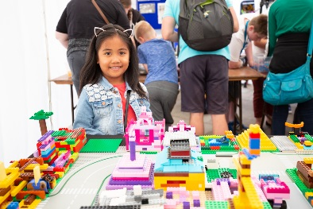
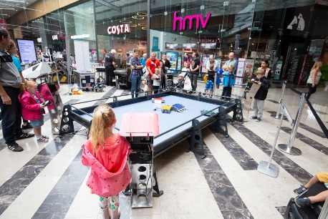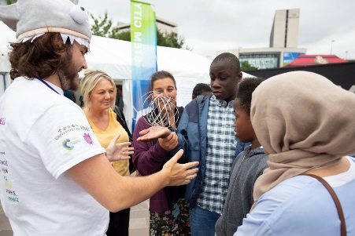
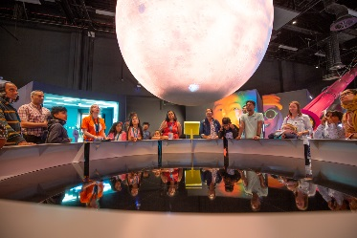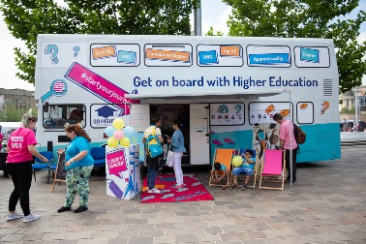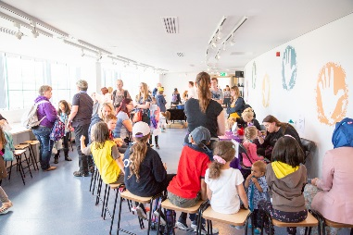
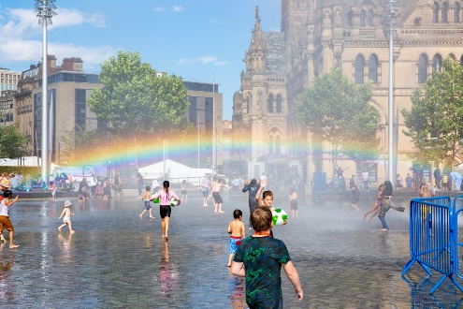

The Festival Team
Bradford Science Festival is produced by the National Science and Media Museum part of the Science Museum Group:
Vicky Clifton: Head of Learning and Participation
Dean Loughran: Head of Operations
Elaine Richmond: Learning Operations Manager
Robin Dark: Partnerships and Learning Projects Manager

How do we programme?
The Festival is produced by the power of collaboration with the National Science and Media Museum leading on headline moments to draw people into the Festival. We call these WOW moments.
The National Science and Media Museum also provides the infrastructure, the marketing (although we appreciate support with this through partners web sites and own social media channels), volunteers, staff and security and therefore we have only a very small budget for content and we want contributors to engage with us to support their own organisational aims working with the festival’s large and diverse audience. Most of the content is provided by contributors free of charge.
Contributor content
Bradford Science Festival invites individuals and organisations, creative practitioners, scientists and previous contributors who wish to contribute to the Festival to submit a proposal for their event/activity idea.

The National Science and Media Museum will curate the Contributor programme by selecting content which reflect our vision, mission, values and programming criteria. All proposals are reviewed by at least three panellists from the Festival team. Representatives from the Science Museum Group and a selection of longstanding partners of the Festival may be invited to peer review proposals.

Visitors to the Festival

Bradford Science Festival attracted, families over the weekend with children in the main of early years and primary school age. The audience is ethnically diverse and broadly reflective of the local population, with 72% being white (2011 Census 68% White) and the second most represented group being Pakistani 12%, (2011 Census 20% Pakistani).

The launch and Lates event attracted a wide age range of adult visitors, with the majority being of white ethnicity (86%).

The Festival attracts visitors from a wide catchment area in Yorkshire.
The Festival primarily programmes events for families. We also invite proposals for events which target specialist visitor groups, such as autism-friendly activities and those that engage underrepresented visitors from Black, Asian and minority ethnic backgrounds.

In 2019, we particularly welcome proposals with a chemistry connection or contribute to the 50th anniversary of the moon landing.
We commission quantitative and qualitative audience research every year and are keen to disseminate the findings with our contributors in early Autumn.

Community Contributor Experience

Community Partnership working is one of the key strengths of our Festival. We collaborate with a wide range of individuals and organisations regionally, nationally and internationally to deliver events taking place across the city centre in our 3 venues:

Here are some of the main reasons our partners work with us:
- Being part of a major and high-profile festival in Bradford
- Opportunity to reach new audiences and raise your profile
- Creating impact through collaboration
- Complimentary training
- Develop B2B relationships to strengthen festival offer
- Promoting science, technology, engineering and maths (STEM)
- Support with delivering events or activities

Some of our 2018 partners included museums, cultural institutions, universities, health organisations, artists, charities and businesses. Here are some comments from our 2018 Festival partners:

“From our side it was an opportunity to increase brand awareness of our business and strengthen partnerships with other organisations. We were interested in the throughput of members of the public and opportunities to contact other stall holders and providers.”

“There were lots of visitors there, it was very busy, well organised, we were very pleased with the outcome.”

“There was a big and varied audience in terms of demographics. There was a real mix of people.”

“We were well supported. The team members were constantly available. We did not feel we were left on our own devices. We felt part of a significant Festival.”

What do we look for in our Contributors?

We have developed programming criteria to help contributors understand what we are looking for from their activities / projects. We welcome proposals for activities which cover some or all the following:

- Are bold, surprising and ambitious
- Connect Bradford Families and young people with the latest in scientific research and promote participation and enjoyment
- Inspire our visitors to explore and be playful with science, making science relevant to them
- Demonstrate high quality in the production and delivery of the activity/event
- Promote originality in the development of the project, the format of the event and the use of new venues in Bradford
- Promote best practice of physical and intellectual accessibility
- Involve new audiences not traditionally engaged with science
- Develop new partnerships

These are the questions our panellists will consider when reviewing partner proposals:

Criteria | Key Considerations
Surprising and ambitious | Is it bold, daring and ambitious?  Is it experimental and cutting edge?  Is the content and/or format unique or original?
Innovation | Is there meaningful science at the heart of the event?  Does the content bring science, technology, engineering and/or mathematics to life?  Are we introducing visitors to something new?  Does it promote participation?  Does it encourage discussion about what visitors are seeing and doing?
Inspiring | Is it fun and inspiring?  Will this appeal to the Festival’s visitors?  Will it drive visitors?  Is it relevant to our visitors’ everyday lives?  Does it embed science as culture?  How does the content reflect the diversity of Bradford District’s population?  Is there evidence that the person submitting the proposal has considered visitor needs?
Quality | Do we have evidence that the content is of high quality?  Will it help raise the Festival’s local, national and international profile?
Pride in the city | Does it showcase Bradford as being a great place to study science?  Does it promote local STEM related careers?  Does it allow partnerships to flourish?
Accessibility | Is it physically and intellectually accessible?  Is the scientific content pitched at the right level for our visitors?  Are there opportunities for deeper engagement? Opportunities to follow up?

Of course we would not expect all of the criteria to be met but when submitting your proposal, please do think how it meets some of these criteria.

Community Contributor Process

21-25 January 2019 | Community Contributor proposal form goes live
28 January – 27 February 2019 | Festival team available to speak to /email potential contributors and answer questions to offer guidance and support
28 February 2019 | Deadline for Community Contributor proposals submitted
4 – 15 March 2019 | Shortlisting Community Contributor proposals
18 – 22 March 2019 | Emails with contractor packs issued to successful proposals
18 -22nd March 2019 | Unsuccessful contributors will be informed by email
25 – 29 March 2019 | Feedback for none successful proposals available
26 March 2019 | Festival Programme confirmed

Additional dates will be issued to successful contributors which outline the dates for submission of contractor forms and the option of attending a training and networking event.

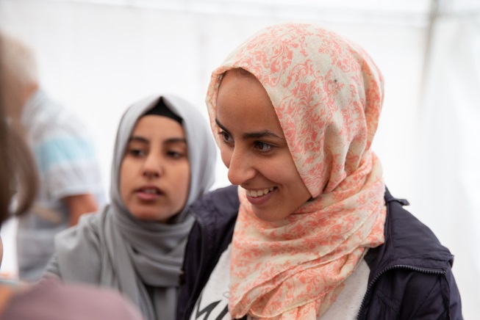

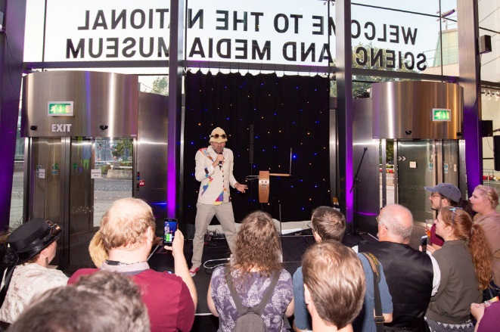

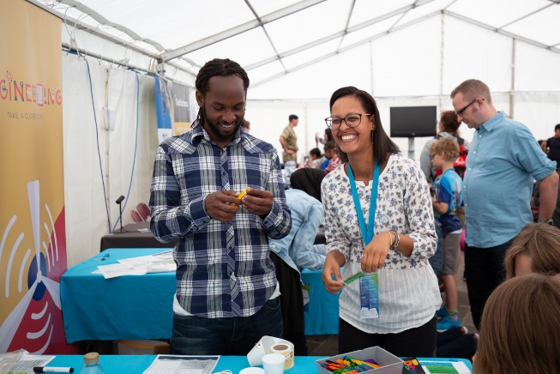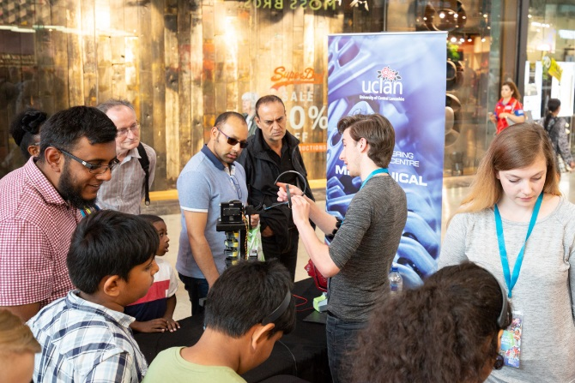

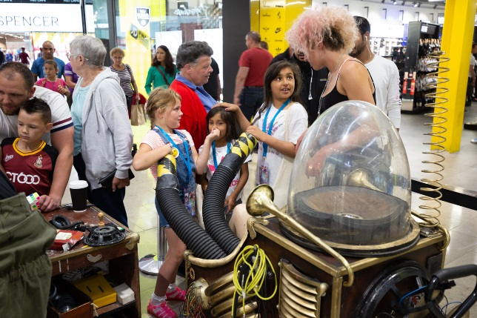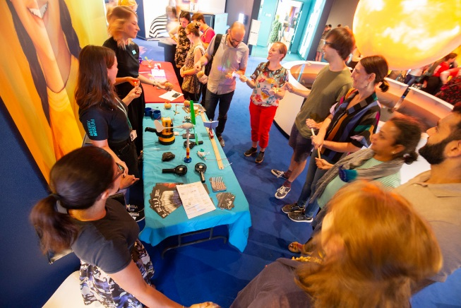

Step by Step guide for Community Contributors

Once confirmed as a Bradford Festival community contributor, there is some key information you will need to know. We have included some of the main points and answers to frequently asked questions below. It is important that you read this before submitting a proposal form, so that you know what to expect, if your proposal is successful.

Event planning and delivery

• Whilst the National Science and Media Museum is responsible for the overall planning and delivery of the Festival programme, partners are responsible for the programming, delivery and health and safety of their own activities.
• The National Science and Media Museum is happy to assist with elements of planning where appropriate. Please discuss this with the Festival team and we will endeavour to support you.
• Partners are responsible for taking care of all logistics and liaison with the Festival to ensure the smooth running of the event.

Event Cost

• Most organisations running events as part of the Festival are responsible for covering their own costs and offer the event to the public for free.
• If you are considering charging for your event, include this in your proposal and a member of the Festival team will contact you to discuss further.
• On occasion, the Festival can make modest financial contributions to support partner activity. Should you require a financial contribution for your activity, please clearly indicate all costs within your proposal.

Communication with the National Science and Media Museum

• It is important that all partners keep in regular communication with NSMM before, during and after the Festival. We ask partners to attend key meetings or send a representative in their place and respond to the deadlines listed in the Festival Contributor timeline. Please let the festival team know in advance if you are unable to attend any scheduled meetings or meet key milestones.

• We would be happy to visit partner organisations and provide their staff and/or volunteers with a Festival programme overview, pre-Festival briefing or any other information you may require.

Science Communication Workshop

• Community Contributors will be offered the following complimentary training and networking event:
Science communication training to support with the creation and delivery of high-quality public engagement events and ensure all events are as open and inclusive as possible.

Branding and Marketing

• The Festival is promoted through press, PR, print, digital marketing and outdoor advertising. Audiences are signposted to the NSMM Festival website through these channels. By being involved in the Festival, community contributors will be included in the Festival marketing strategy, on the Festival website and may be chosen for inclusion in additional promotional activity.
• We strongly encourage contributors to support the overall promotion of the Festival by publicising their own events. It’s likely that our contributors will have access to channels and networks that will enhance our overall campaign. We ask that contributors let us know what their communications plans are – this will help us to be more resourceful, to align our communications and to ensure they are within the brand guidelines.
• Some contributors activities could particularly appeal to press and may feature more prominently in our communications. We will work closely with contributors where this is the case, though please note that communication support for individual activities cannot be guaranteed.
• Activities should be promoted as part of the Bradford Science Festival and contributors must ensure there is a Bradford Science Festival brand presence during the event.
• Contributors should adhere to the Bradford Science Festival brand guidelines and obtain sign-off by the Festival team before producing their own materials that include Festival branding.
• All promotional material for events taking place at the Science and Media Museum must be signed off with the Museums marketing team. This includes flyers, posters, banners and any other marketing or branded materials.
• The Festival will work within contributor guidelines wherever requested. Contributors are asked to send their brand guidelines (if applicable) to the Festival team when sending their logos, images and copy.

Copywriting

• When submitting a proposal for the programme, contributors will be asked to provide us with an activity title and details. The proposal details need to accurately reflect the content and format of the activity. Most importantly, you need to be able to tell us exactly what people
can see, do, hear, feel, touch and experience at your event. Quirky facts, quotes, comparisons and relatable analogies are also helpful.

• Please don’t worry about making your copy creative and exciting, we employ a professional copywriter who will use the details you provide and ensure your event complements the tone of the wider programme.

Digital content
• Online audiences respond well to video content, so please send us any relevant video content that you may have throughout the course of planning and delivering your festival event.

• Blog content for the Science Festival is also popular, so if you are inspired to write a blog piece about your event or about the themes related to your event, please get in touch with the Festival team.

Logos and images

• Any logos and images supplied must have full online and offline publication rights and must be cleared for use for Festival promotion.
• By sending us logos and images, you are allowing us to use them, but there is no guarantee that they will be used. Images may be used across all media platforms.
• Logos on printed materials are reserved for sponsors. Please let us know if you are interested in any of our logo sponsorship packages.

Press and PR
During key points of the year, there will be a focus on PR activity, with the aim of
generating local, regional and national media coverage.
• We ask all contributors to reference Bradford Science Festival in the opening paragraph
of any press releases they generate and again in the Editors’ Notes where a boiler plate
on Bradford Science Festival must be included. These releases must be signed off by the Festival team prior to release.

• Contributors are asked to share press and PR plans and schedules with the Festival team so we
can keep track of all external PR activity and potential clashes.

• Contributors are asked to make the Festival team aware of the relevant spokes people from the
organisation so we can offer them up for interviews where applicable.

Photography and video
• The Science and Media Museum will hire photographers to capture images and video from selected events at the Festival.

• Photographers will be responsible for ensuring completion of photography consent forms.

•Contributors are welcome to use images from their event for promotional purposes. However,
as the copyright will be held by the Science Museum Group, all images must be credited appropriately and not used for commercial purposes.

Volunteering
• The Festival will recruit volunteers and STEM ambassadors to support the delivery of activities, all contributors are able to request volunteers / STEM ambassadors to assist them, although we cannot guarantee that we will be able to provide contributors with the full number of volunteers requested for each day.

• It is the responsibility of each contributor to ensure that Festival volunteers / STEM ambassadors are given a full briefing and assigned appropriate tasks, given the opportunity to ask questions and have scheduled breaks in line with legal guidelines.

• The Festival encourages contributors to sign up to our STEM ambassador’s program information on how to go about registering will be sent out with the contractor paperwork.

Ticketing

• Whilst most Festival events are free, some of these are ticketed and others may include a small charge. The Festival has its own in-house ticketing system (Tessitura) and will set-up and manage ticketed events on behalf of our contributors to provide a more streamlined and comprehensive experience for Festival visitors. We will send contributors regular updates on ticket booking figures.

• Visitors will be asked whether they would like to have their details used by the Festival and its partners for promotional and evaluation purposes. All data will be captured and shared according to General Data Protection Regulation (GDPR) guidelines.

Research and Evaluation

•Bradford Science Festival offers a great opportunity to work collaboratively to generate useful visitor data. We will undertake an evaluation programme which may include the use of interactive displays, Vox pops, evaluation, in person and e-surveys, and data captured via the ticketed system Tessitura. Where applicable, our external evaluation consultant will ask to work more closely with contributors to help collect specific feedback or gain specific insights.

• As part of the Festival, contributors will be expected to support our evaluation process and provide us with information from their events. This includes counting visitor numbers and submitting these to the team after the Festival. We will share event data with partners after the Festival, once evaluation forms and all other data sets have been analysed by external evaluators.

• Contributors are asked to make the Festival aware of any of their own evaluation plans so we
can use data effectively to cross promote events and to avoid duplication with overall festival evaluation.

• Contributors need to ensure that in collecting any additional visitor data, they are adhering to
GDPR guidelines

We simply couldn’t exist without the support of we receive from our remarkable sponsors, partners contributors and friends, all of whom help us create a wealth of fantastic science experiences. If your company or organisation is interested in additional profiling and exposure, over and above your own event at the Festival, we have sponsorship opportunities available. Please contact a member of the festival team if you would like more information.
• Contributors are responsible for financing their events, unless otherwise agreed with the Festival team.
• On occasion, we may wish to assign Festival sponsors to partner activities but will discuss this in advance if this is relevant.
• We ask contributors not to distribute fundraising material during Festival events.

• Accessibility is one of the core values of the Festival and we strive to make each event as open and accessible as possible. We ask all contributors to consider physical and intellectual access when planning their activities.
• Contributors are responsible for the safety of their activities and the public attending. Contributors should ensure they are covered by their own Public Liability Insurance (PLI) – The Festival team will require a copy of contributors PLI in line with our health and safety policy.
• Contributors are responsible for general health and safety at their activity and must complete a thorough risk assessment and method statement for each event. This needs to consider risk implications of both the activity venue and use of Festival volunteers. The Festival team can provide contributors with guidance around completing risk assessments and method statements.
• All contributors will be required to complete all Bradford Science Festival H&S documentation.

• Contributors are responsible for embedding briefing information within their staff team.
We hope this information has been useful – it’s certainly not an exhaustive guide to being
involved in Bradford Science Festival, so if you have any queries, please just get in touch.
Read the information pack and ready to apply? Please complete our Community Contributor proposal form

Bradford Science Festival Launch Party – Thursday 18th July
Festival dates – Thursday 18th July – Sunday 21st July 2019

Festival Email: Bradfordsciencefestival@scienceandmediamuseum.org.uk
Website: https://www.scienceandmediamuseum.org.uk/bradford-science-festival-2019

Festival contacts:
Vicky Clifton, Head of Learning and Participation:

Operational enquiries
Elaine Richmond, Learning Operations Manager:

General enquiries
Robin Dark, Partnerships and Learning Projects Manager:

Thank you for your interest in Bradford Science Festival 2019

